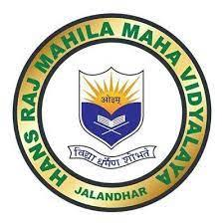

7.1.9
Sensitization of students and employees of the Institution to the constitutional obligations: values, rights, duties and responsibilities of citizens
ANY OTHER RELEVANT INFORMATION

Wednesday, 10 January 2024

“Prestigious Arjuna Award Bestowed upon HMV’s Para Canoeing Sensation Prachi Yadav"
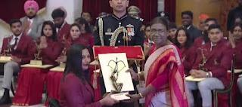
https://hmvnews.blogspot.com/2024/01/prestigious-arjuna-award-bestowed-upon.html

In a luminous celebration of victory, Hans Raj Mahila Maha Vidyalaya proudly unveils the remarkable success – the prestigious Arjuna Award conferred upon the gifted para canoeist, Km. Prachi Yadav. This coveted accolade stands as a shining testimony to Prachi's unwavering dedication, exceptional skill, and unmatched sportsmanship, particularly in the challenging realm of Para Canoeing. With a heart brimming with pride, Principal Prof. Dr. (Mrs.) Ajay Sareen extends her heartfelt congratulations to Prachi Yadav for achieving this monumental milestone. Prof. Sareen emphasizes that her accomplishments have not only elevated her status as Sports Woman but have also cast a radiant glow upon the entire HMV community. The Principal applauds her for her exceptional dedication, resilience, and indomitable spirit that have set her apart on the path to excellence. Dr. Sareen also extended her thanks and felicitations to DAVCMC, New Delhi, Local Advisory Committee, faculty, staff and students. Prachi Yadav's recent triumphs at the Asian Para Games-2023 in China, where she clinched Gold and Silver medals in the Para Canoeing event, further underscore her prowess on the international stage. The Sports Authority of India, recognizing Prachi's outstanding achievements, joined in the chorus of accolades, extending their congratulations through their official Facebook Page. As the HMV community rejoices in her success, the institution stands united in offering warmest congratulations to this inspirational athlete. The triumphs of Prachi Yadav serve as a beacon of inspiration for aspiring Sports Women, resonating with HMV's commitment to nurturing talent and fostering excellence in the realm of sports. President DAVCMC Padamshree Dr. Punam Suri and Chairman Local Advisory Committee Justice (Retd.) Sh. N.K. Sud also congratulated her on her success.
Thursday, 11 January 2024

HMV's Pivotal Contribution Leads GNDU to 25th MAKA Trophy Victory
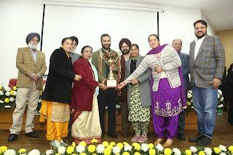
https://hmvnews.blogspot.com/2024/01/hmvs-pivotal-contribution-leads-gndu-to.html

In a historic achievement, Guru Nanak Dev University, Amritsar has clinched the prestigious MAKA Trophy for the 25th time, cementing its position as a powerhouse in the world of sports. Vice-Chancellor, Dr. Jaspal Singh, was honored to receive the trophy from the esteemed President, Smt. Droupadi Murmu, marking a momentous occasion for the university. At the heart of this remarkable success stands the unwavering support and unparalleled dedication of the sports enthusiasts at Hans Raj Mahila Maha Vidyalaya, whose collective efforts have propelled GNDU to the pinnacle of sporting excellence by contributing maximum points. HMV, known as ‘Nursery of Olympians,’ with its rich history and commitment to holistic development, has consistently demonstrated a deep-seated passion for nurturing athletic talent. The institution's sports programme, under the guidance of Principal Prof. Dr. (Mrs.) Ajay Sareen, dedicated coaches and mentors, has been instrumental in honing the skills of the athletes, contributing significantly to their stellar performances on the International and National stage. Speaking about HMV's role in this remarkable achievement, Dr. Jaspal Singh, the Vice-Chancellor of GNDU, expressed his gratitude, stating, "HMV has been a cornerstone in our journey to success. The commitment and hard work of the athletes, coupled with the support and infrastructure provided by HMV, have been pivotal in achieving this milestone." The MAKA Trophy, symbolizing excellence in inter-university sports, is awarded annually to the university that excels in various sporting disciplines. GNDU's consistent triumphs underscore the institution's commitment to fostering a culture of sportsmanship and athleticism. The administration and win. They remain steadfast in their dedication to providing a nurturing environment for sports, ensuring that future generations of athletes continue to shine on both regional and national platforms.

Thursday, 18 January 2024

HMV Clinches the title of Best College
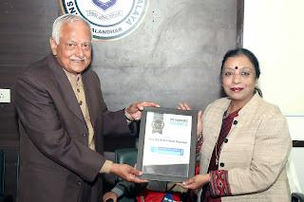
https://hmvnews.blogspot.com/2024/01/hmv-clinches-title-of-best-college.html

Hans Raj Mahila Maha Vidyalaya, Jalandhar proudly cherishes its latest achievement as it has been declared as the Best Arts, Science, and Commerce College in a recent survey conducted by the esteemed monthly magazine, Academic Insights. This recognition further reinforces HMV's standing as a leader in higher education, adding to its already impressive array of accolades. The achievement reflects the collaborative efforts of the entire HMV family and the leadership of Principal Prof. Dr. (Mrs.) Ajay Sareen, whose guidance has been instrumental in steering the institution toward success. In expressing her gratitude, Principal Dr. Sareen acknowledges the unwavering support received from the mentors of the DAV College Managing Committee, New Delhi and the Local Advisory Committee. She also commends the dedicated efforts of the project coordinator, Dr. Anjana Bhatia, as well as all Heads of Departments, faculty members, staff, students, and stakeholders who have played a crucial role in this success. Under the inspiring guidance of President DAVCMC Padma Shri Dr. Punam Suri, Director Higher Education Sh. Shiv Raman Gaur IAS(Retd.), and Vice President DAVCMC and Chairman Local Advisory Committee Justice (Retd.) Sh. N.K. Sud, HMV continues to thrive and make significant strides in the field of education.Justice Sh. N.K Sud honoured Principal Ajay Sareen and said that HMV is a glorious institution that is continuously scaling new zeniths under the visionary leadership of Principal Dr. Sareen. The enthusiastic HMVians celebrate this achievement with pride and commit to channeling even greater passion and dedication towards the continuous improvement and betterment of their esteemed institution.

Saturday, 27 January 2024
Honouring Excellence in Sports: Principal Prof. Dr.(Mrs.) Ajay Sareen honoured on 26 January,2024
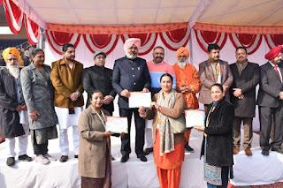

https://hmvnews.blogspot.com/2024/01/honouring-excellence-in-sports.html

On the auspicious 26th of January 2024, a day resonating with the spirit of our nation, Principal Prof. Dr. (Mrs.) Ajay Sareen was bestowed with a prestigious honour for her exceptional contributions to the realm of sports. The recognition was graciously presented by the Honourable Deputy Commissioner of Jalandhar, Shri Vishesh Sarangal, in the esteemed presence of Honourable Shri Harpal Singh Cheema, Minister of Finance for the Government of Punjab, and Respected MLA Shri Sushil Rinku, alongside the revered Sant Seechewal. Dr. Sareen's dedication, leadership, and commitment have not only sculpted the sports culture but have also been a wellspring of inspiration for countless students to pursue excellence. Dr. Navneet and Mrs. Ramandeep from the Sports Department, were yet another among the chosen one to receive the Appreciation for their dedication and diligence. In her gracious acceptance speech, Principal Dr. Sareen expressed her profound gratitude to the Almighty and the DAV College Managing Committee. She congratulated the Sports Department for its exceptional achievements and bringing honour to the name of the institution. She reaffirmed her unwavering commitment to the betterment of society and the nation, vowing to continue her efforts in driving positive change. HMV’s achievements consists of a long list. In a historic moment, HMV proudly played a pivotal role with maximum contribution to Guru Nanak Dev University's triumph in the MAKA Trophy, further solidifying institution's commitment to excellence in sports. HMV has recently clinched the Women Champions Trophy 2023 which is a testament to the hard work and perseverance of its athletes, coaches, and the entire Sports department. HMV’s talented player, Prachi Yadav, was awarded with the prestigious Arjuna Award for her outstanding performance and dedication to her sport. Another shining, Harmilan Bains, brought glory to HMV by winning medals in the Asian Games 2023. Her achievements on the international stage showcase the caliber of athletes nurtured within the campus. These accomplishments underline the unwavering dedication to fostering a holistic learning environment that not only focuses on academic brilliance but also encourages the pursuit of excellence in sports.

Thursday, 8 February 2024
HMV Won Overall 2nd Runners up Trophy at Rangmanch 3.0
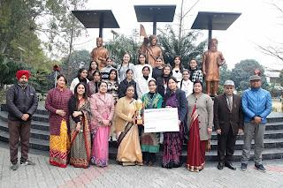
https://hmvnews.blogspot.com/2024/02/hmv-won-overall-2nd-runners-up-trophy.html

The students of Hans Raj Mahila Maha Vidyalaya participated in “Rangmanch 3.0”, an inter college competition organized by CT Group of Institution under the able guidance of Principal Prof. Dr. (Mrs.) Ajay Sareen The team of Business Plan stood 1st comprising of Sakshi Vaid and Kris Sondhi. Gursimar Kaur won 1st prize in Mehandi, Sofia got 1st prize in Gazal. Group dance team won 3rd prize which consisted of Mansi, Ragini Kapur, Alphansa, Charanjeet, Manroop, Gargi. Jashan and Sunakshi. HMV bagged 2nd Runners Up Trophy along with a cash prize of Rs. 5000/-. Principal Prof. Dr. (Mrs.) Ajay Sareen congratulated the team and Dean Youth Welfare Mrs. Navroop and respective incharges for the prizes. She said that the students of HMV are talented and they always make us proud.

Tuesday, 20 February 2024

Harmilan Bains Clinches Gold in Asian Championships, Adding to Asian Games Success
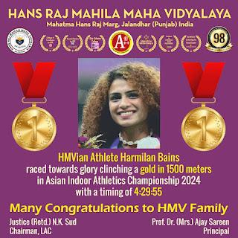

https://hmvnews.blogspot.com/2024/02/harmilan-bains-clinches-gold-in-asian.html

Harmilan Bains, the promising athlete representing HMV, has once again etched her name in the annals of sporting history by securing the gold medal in the prestigious Asian Indoor Athletics Championship in 1500 metres with a timing of 4:29:55. Harmilan, who had initially made waves with her remarkable performance in the Asian Games, continues to soar to greater heights, showcasing her prowess on the international stage. With this latest victory, she adds yet another milestone to her illustrious career, solidifying her position as one of the most formidable athletes in the region. Principal Prof. Dr. (Mrs.) Ajay Sareen extended warm congratulations to Harmilan Bains for her outstanding performance. She commended her dedication, hard work, and exemplary representation of the institution on the international stage, expressing pride in her achievement. Having previously clinched two medals in the Asian Games, her latest achievement underscores her consistency and determination to excel in her sport. Commenting on her victory, Harmilan Bains expressed gratitude to Principal Dr. Ajay Sareen, teachers, supporters, coaches, and sponsors for their unwavering support throughout her journey. She dedicated her success to her team and vowed to continue pushing boundaries and striving for greater achievements in the future. The Management at HMV extends its heartfelt congratulations to Harmilan Bains on this remarkable feat. Her victory not only brings pride to the organization but also reinforces its commitment to nurturing

Saturday, 16 March 2024
SHEROES Awards 2024 Organized in HMV
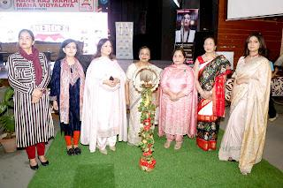

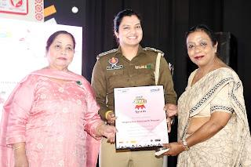
https://hmvnews.blogspot.com/2024/03/sheroes-awards-2024-organized-in-hmv.html

Hans Raj Mahila Maha Vidyalaya Jalandhar, in collaboration with Radio City and Lakme Academy, organized SHEROES Awards 2024. SHEROES Awards is an uplifting event where women and young girls from all walks of life who inspire, empower and impact are celebrated equally in one big award ceremony. The event commenced with the lighting of the lamp followed by DAV Gaan. The guest and the Jury Panelists of the event were Principal Prof. Dr. (Mrs.) Ajay Sareen, Dr. Sushma Chawla, Ms. Parveen Abrol, Social Activist, Mrs. Seema Chopra, Journalist & Social Activist. Principal Prof. Dr. (Mrs.) Ajay Sareen honored the guests with the green planters. In her addressed she encouraged the audience to always keep on doing thing to uplift their identity in the society since the best is yet to come. The stage was taken over by RJ Loveena and RJ Sandy and RJ Himanshu from Radio City. RJ Loveena threw light on the title of the event Sheroes. Ms Seema Soni presented a token of love and respect to the jury panelists. Total twenty-three awardees who excelled in various fields, including sports, social media influencing, life-style coaching and NGO, were appreciated and honoured with souvenirs by the jury panelists. The names included Harpal Kaur, Meena Kumari, Priya Tiwari, Hashmat Sultana, Kamyani, Mallika Handa, Manpreet Kaur Patti, MK Sanjh, Neha Manhas, Sudesh Kumari, Trishla Sharma, Anamika Sandhu, Farah Sanjna, Jaspreet, Jyoti Nooran, Neeru Jairath, Rasneet, Sugandha Sharma, Swati Sabharwal, Anvita Chatwaal, Dolly Mehta, Dr. Randeep Kaur Sidhu, Harmillan Kaur Bains. It was followed by various cultural performances and songs. The overall in-charges of the events were Mrs. Navroop and Dr. Anjana Bhatia. The members of the Student Council were also present. The event concluded with the recitation of National Anthem.

Monday, 18 March 2024
Mrs. Navroop Kaur of HMV took part in World Punjabi Conference at Lahore
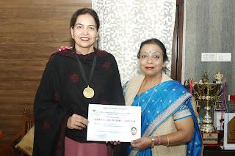
https://hmvnews.blogspot.com/2024/03/mrs-navroop-kaur-of-hmv-took-part-in.html

Mrs. Navroop Kaur, Head of Punjabi Department of Hans Raj Mahila Maha Vidyalaya participated in 33rd World Punjabi Conference held at Lahore. Principal Prof. Dr. (Mrs.) Ajay Sareen congratulated Mrs. Navroop Kaur for this achievement, Mrs. Navroop Kaur told that this conference was a 3 days conference. During the valedictory session of the conference all the participants from India were honoured by Pakistan dignitaries. She said that Indian writers and poets were given a very warm welcome there in Lahore. Pakistani Punjabi writers are also doing great job for Punjabi Language. During this conference, cultural programmes were also organized by singers of Pakistan and India. The contingent from India also visited Nankana Sahib and Kartarpur Sahib. Mrs. Navroop Kaur also presented her paper titled “Punjab De Lok Nayak Parampare Ate Pratiman.” She also shared her experience of visiting Lahore with her colleagues.

Monday, 8 April 2024

HMV won Inter College Swimming Tournament
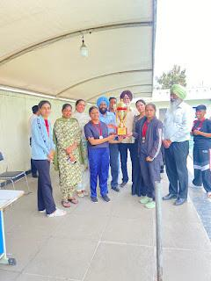

https://hmvnews.blogspot.com/2024/04/hmv-won-inter-college-swimming.html

The Swimming Team of Hans Raj Mahila Maha Vidyalaya, Jalandhar won Inter College Swimming (M&W) Tournament organized by Guru Nanak Dev University, Amritsar. This Tournament was held at Hans Raj Mahila Maha Vidyalaya, Jalandhar. In this championship, HMV defeated Khalsa College for Women, Amritsar. Principal Prof. Dr. (Mrs.) Ajay Sareen congratulated the team coach Mr. Umesh Sharma and Players. On this occasion, from GNDU Mr. Rajesh Kumar and Mr. Pishora Singh, Dean Youth Welfare HMV Mrs. Navroop, from HMV Dr. Navneet Dhadda, Mrs. Ramandeep Kaur and Ms. Pragati were also present.

Tuesday, 23 April 2024
The Knowledge Review declares HMV as the best destination to study Psychology and Commerce -2024 at the national level
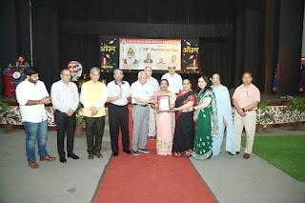

https://hmvnews.blogspot.com/2024/04/the-knowledge-review-declares-hmv-as.html

The visionary, innovative and vibrant guidance of Principal Prof. Dr. (Mrs.) Ajay Sareen has ushered a golden age for Hans Raj Mahila Maha Vidyalaya with the institution achieving new milestones every day. Continuing its legacy of attaining greater heights in the field of education, HMV has successfully added another feather in its cap. PG Department of Commerce and Management has been honoured by the Knowledge Review Magazine in an annual listing of the most excellent institute to study commerce, 2024. Furthermore, the PG department of Psychology has also registered its compelling presence as the best department at the national level. It is a matter of pride for the institution and all the stakeholders as HMV has embarked a name for itself due to its commitment to academic excellence, innovation and dedication to nurturing future leaders. The elated and jubilant HMV family congratulated Principal Dr. Sareen for the glorious achievement. Principal Prof. Dr. (Mrs.) Ajay Sareen said that the accolade comes as no surprise to the stakeholders of HMV as the institute has gloriously established itself as a bastion of educational innovation and intellectual growth. With state-of-the-art facilities and a dynamic curriculum designed to meet the demands of the modern workforce, the college has consistently raised the bar for educational standards in the region. The elated principal congratulated Dr. Ashmeen Kaur, IQAC Coordinator and Head of PG Department of Psychology, Mrs. Meenu Kohli, Head of the PG Department of Commerce and Management, project Coordinator Dr. Anjana Bhatia and all the faculty members, staff, students and stake holders. She said that HMV feels blessed to work under the inspiring directions of President DAVCMC Padamshri Dr. Punam Suri, Director Higher Education (Retd.) IAS Sh. Shiv Raman Gaur and Vice President DAVCMC and Chairman Local Advisory Committee Justice (Retd.) Sh. N.K. Sud. On the occasion, Sh. Ajay Kumar Goswami, Secretary, DAVCMC, Dr. Pawan Gupta, Sh. S.P. Sehdev, Dr. Sushma Chawla, Dr. Sudhir Sharma, Sh. Atul Mayor and Mr. Surjit Lal were present.

Wednesday, 1 May 2024

‘Prati-Abhar’ 2024 for Supporting Staff Organized in HMV
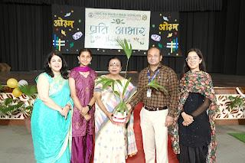

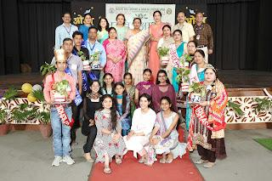

https://hmvnews.blogspot.com/2024/05/prati-abhar-2024-for-supporting-staff.html

Under the direction and able guidance of dexterous Principal Dr. (Mrs.) Ajay Sareen, and with the assistance of Mrs. Savita Mahendru (Coordinator of student’s council cell) and supported by Mr. Ravi Maini (Superintendent Admin), a programme named ‘Prati-Abhar’ 2024 was successfully organized for Supporting Staff in Hans Raj Mahila Maha Vidyalaya, Jalandhar. Principal of the college Dr. Ajay Sareen was the chief guests of the occasion. Dr. Sareen was warmly welcomed with a green planter. The programme was commenced by lighting the pious lamp and following the ‘DAV Gaan’. Principal Dr. Sareen welcomed all the Non-Teaching staff of the college and said that HMV is only the first North’s academic organization which organizes such sort of programme for its’ Non-Teaching staff. Further, in her address, Dr. Sareen congratulated the entire team of student’s council and all the members of Non-Teaching staff for making the occasion successful. In addition to this, Principal Sareen told that the main endeavor for organizing this function is to convey that work is worship and we must not consider any work high or low. We must always respect to our employee which is also a moral duty of all of us. Principal Sareen said that it is with the incessant efforts of staff members that any institution grows and become successful. Dr. Sareen wished that a positive relation between institution and its’ employees will always be remained for the upliftment of organization. On this eve, members of supporting staff presented dance, modeling, and played various games. Mrs. Navroop, Mrs. Deepshikha, and Mr. Lakhwinder Singh acted as judges for modeling competition. Sh. Madan Lal as ‘Bade Dilwala’, Sh. Raj Kiran as ‘Gatisheel’, Sh. Vikas as Khiladi No. 1. and Sh. Vipan Kumar as ‘Pratibasheel’ were selected in Male while in Female, Smt. Rajni as ‘Sweet Smile’, Smt. Sona as ‘Mutiyaar’, Smt. Manisha as ‘Pratibavaan’ were selected. All the winners were awarded with planters and various attractive prizes. Under the surveillance of Mrs. Protima Mander, the stage for entire programme was conducted by the team of Student Council. Mrs. Savita Mahendru delivered a vote thanks to all at the end of the occasion.

Wednesday, 22 May 2024

Cycling Team of HMV Won Gold
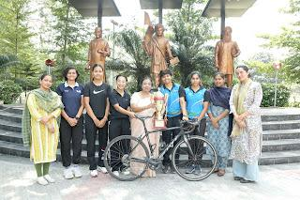

https://hmvnews.blogspot.com/2024/05/cycling-team-of-hmv-won-gold.html
The Cycling Team of Hans Raj Mahila Maha Vidyalaya, Jalandhar won Gold in Cycling Championship in Inter College held at GNDU Campus. The team members were Shiya, Sanskriti, Sadnya, Leakes. Principal Prof. Dr. (Mrs.) Ajay Sareen congratulated the coach of the team Mr. Rajesh, cyclists and faculty members. On this occasion Dr. Navneet Dhadha, Mrs. Ramandeep Kaur and Ms. Pragati were also present.

Monday, 10 June 2024

HMV Wins Prestigious District Environment Award 2024-25
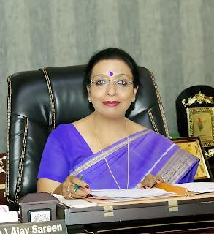
https://hmvnews.blogspot.com/2024/06/hmv-wins-prestigious-district.html
Under the able, dedicated and committed stewardship of Principal Prof. Dr. (Mrs.) Ajay Sareen, Hans Raj Mahila Maha Vidyalaya has been honored with the District Environment Award for 2024-25, recognizing its outstanding contributions to environmental conservation and sustainability. The accolade was awarded by the National EduTrust of India. Principal Dr. Ajay Sareen expressed her gratitude to Dr. Punam Suri, President of DAVCMC, and Justice (Retd.) N.K. Sud, Chairman of the Local Committee (LC), along with all other mentors from DAVCMC and LC, for their unwavering support and guidance. Principal Sareen further added that various environment initiatives like Aashiyana, Aabo Hawa, HMV eTREE, paper recycling have been taken up to raise awareness regarding Environment Conservation and Restoration. She congratulated HMV Stakeholders for their consistent support. Dr. Anjana Bhatia, the project coordinator, highlighted that HMV was selected based on several key parameters, including resource conservation, recycling efforts, and environmental awareness initiatives.
Samarth Sharma, Chief Executive Officer of the National EduTrust of India states that HMV has remarkably contributed to promotion of environmental conservation and their efforts towards sustainability are truly commendable.

